**UCS 2312 Data Structures Lab**

**Exercise 12: Implementation of Hash Table using Closed and Open addressing methods**

**Date of Assignment: 11.12.2023**

The HashTableADT contains hash table and its size. Hash function to be used for the insertion of elements is ***x mod tableSize***. Use Separate chaining method to resolve the collision.

* void init(HashTableADT *H) – To initialize the size of Hash Table
* void insertElementL (HashTableADT *H, int x)– To insert the input key into the hash table
* int searchElement(HashTableADT *H, int key) – Searching an element in the hash table, if found return 1, otherwise return -1
* void displayHT(HashTableADT *H) – Display the elements in the hash table

1. Demonstrate ADT with the following test case

insert 23, 45, 69, 87, 48, 67, 54, 66, 53

2. Create another hash table ADT with following functions for open addressing methods, namely, Quadratic probing and Double Hashing.

* void insertElementL (HashTableADT *H, int x)– To insert the input key into the hash table
* void displayHT(HashTableADT *H) – Display the elements in the hash table

Note: For Double hashing, the second hash function is 7-(x%7)

**Algorithm –**

**Algorithm: Separate Chaining (Insertion)**

Input – Pointer to Hash Table, data x to be inserted

Output – void

1. Create a node.
2. node->data=x
3. h=x%size
4. ptr=H->list[h]
5. while(ptr->next!=NULL

ptr=ptr->next

1. ptr->next=node

**Algorithm: Quadratic Probing (Insertion)**

Input – Pointer to Hash Table, data x to be inserted

Output – void

1. flag=1
2. for i=0 to size

pos=(x+(i*i))%size

if(H->table[pos]==-1

H->table[pos]=x

Flag=0

Break

1. if flag==1

print Table is Full

**Algorithm: Double Hashing (Insertion)**

Input – Pointer to Hash Table, data x to be inserted

Output – void

1. flag=1
2. prime=first prime number smaller than size
3. for i=0 to size

hash2=prime-(x%prime)

pos=((x%size)+(i*hash2))%size)

if(H->table[pos]==-1

H->table[pos]=x

Flag=0

Break

1. if flag==1

print Table is Full

**hash1.h code:**

//separate chaining

struct node

{

int data;

struct node* next;

};

struct hashtable

{

int s;

struct node* list[100];

};

void create (struct hashtable *H, int size)

{

H->s = size;

for (int i=0;i< H->s; i++)

{

H->list[i] = (struct node*)malloc(sizeof(struct node));

H->list[i]->next = NULL;

}

}

void insert (struct hashtable *H, int x)

{

struct node* temp = (struct node*)malloc(sizeof(struct node));

temp->next = NULL;

temp->data = x;

int h = x % H->s;

struct node* ptr = H->list[h];

while (ptr->next!=NULL)

{

ptr = ptr->next;

}

ptr->next = temp;

}

void print (struct hashtable *H)

{

for (int i=0;i<H->s;i++)

{

printf ("\n%d - ", i);

struct node* header = H->list[i];

struct node* ptr = header->next;

while (ptr!=NULL)

{

if (ptr==header->next)

printf (" %d ", ptr->data);

else

printf (" -> %d", ptr->data);

ptr = ptr->next;

}

}

printf ("\n");

}

void search (struct hashtable *H, int x)

{

int h = x % H->s;

struct node* ptr = H->list[h];

while (ptr->next!=NULL)

{

ptr = ptr->next;

if (ptr->data==x)

{

printf ("\nElement %d found.\n", x);

return;

}

}

printf ("\nElement %d not found.\n", x);

}

**hash1.c code:**

//separate chaining

#include <stdio.h>

#include <stdlib.h>

#include "hash1.h"

void main ()

{

struct hashtable* H = (struct hashtable *)malloc(sizeof(struct hashtable));

create (H,10);

insert(H,23);

insert(H,45);

insert(H,69);

insert(H,87);

insert(H,48);

insert(H,67);

insert(H,54);

insert(H,66);

insert(H,53);

print (H);

search (H,45);

search (H,67);

search (H,12);

}

**hash2i.h code:**

struct hashtable

{

int size;

int table[100];

};

void create (struct hashtable *H, int size)

{

H->size = size;

for (int i=0;i< H->size; i++)

{

H->table[i]=-1;

}

}

void insert (struct hashtable *H, int x)

{

int pos,flag=1;

for(int i=0;i<H->size;i++)

{

pos=(x+(i*i))%(H->size);

if(H->table[pos]==-1)

{

H->table[pos]=x;

flag=0;

break;

}

}

if(flag)

{

printf("Hash Table is full.\n");

}

}

void display (struct hashtable *H)

{

printf("Hash Table Elements : ");

for(int i=0;i<H->size;i++)

{

if(H->table[i]!=-1)

{

printf("%d ",H->table[i]);

}

}

printf("\n");

}

**hash2i.c code:**

//double hashing

#include <stdio.h>

#include <stdlib.h>

#include "hash2i.h"

void main ()

{

struct hashtable* H = (struct hashtable *)malloc(sizeof(struct hashtable));

int choice=1,size,data;

printf("Size = ");

scanf("%d",&size);

create(H,size);

while(choice)

{

printf("\n1.Insert\n2.Print\nChoice : ");

scanf("%d",&choice);

switch(choice)

{

case 1:

printf("Element = ");

scanf("%d",&data);

insert(H,data);

break;

case 2:

display(H);

break;

}

}

}

**hash2ii.h code:**

#include <stdio.h>

struct hashtable

{

int size;

int table[100];

};

void create (struct hashtable *H, int size)

{

H->size = size;

for (int i=0;i< H->size; i++)

{

H->table[i]=-1;

}

}

int primeNo (struct hashtable *H)

{

int c=0;

for(int i=H->size-1;i=0;i--)

{

c=0;

for(int j=1;j<=i;j++)

{

if(i%j==0)

{

++c;

}

}

if(c==2)

{

return i;

}

}

}

void insert (struct hashtable *H, int x)

{

int pos,flag=1,hash2,prime;

prime=primeNo(H);

for(int i=0;i<H->size;i++)

{

hash2=prime-(x%prime);

pos=((x%H->size)+(i*hash2))%(H->size);

if(H->table[pos]==-1)

{

H->table[pos]=x;

flag=0;

break;

}

}

if(flag)

{

printf("Hash Table is full.\n");

}

}

void display (struct hashtable *H)

{

printf("Hash Table Elements : ");

for(int i=0;i<H->size;i++)

{

if(H->table[i]!=-1)

{

printf("%d ",H->table[i]);

}

}

printf("\n");

}

**hash2ii.c code:**

//double hashing

#include <stdio.h>

#include <stdlib.h>

#include "hash2i.h"

void main ()

{

struct hashtable* H = (struct hashtable *)malloc(sizeof(struct hashtable));

int choice=1,size,data;

printf("Size = ");

scanf("%d",&size);

create(H,size);

while(choice)

{

printf("\n1.Insert\n2.Print\nChoice : ");

scanf("%d",&choice);

switch(choice)

{

case 1:

printf("Element = ");

scanf("%d",&data);

insert(H,data);

break;

case 2:

display(H);

break;

}

}

}

**Output Screen:**

**Separate Chaining-**

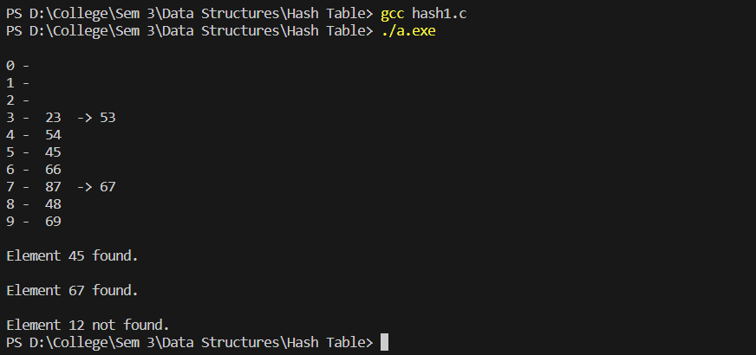

**Quadratic Probing-**

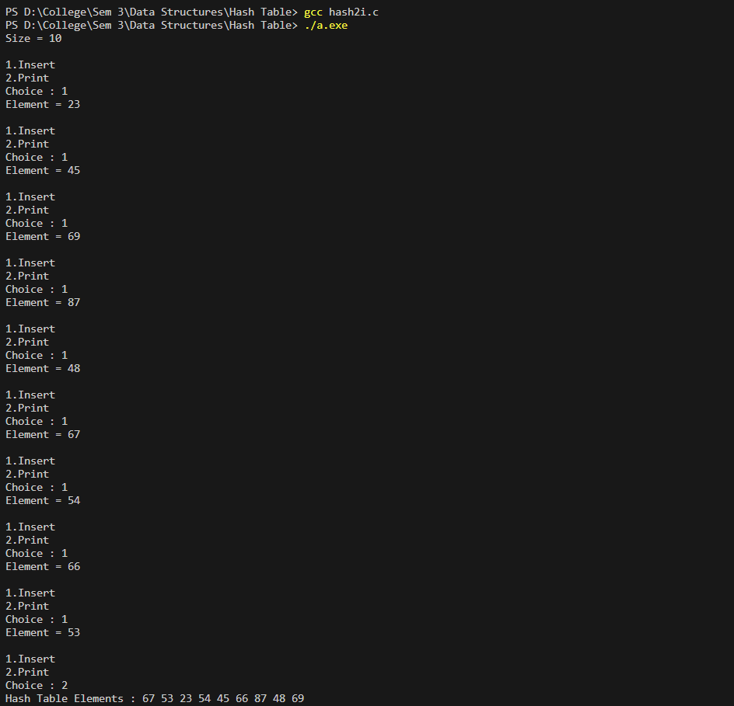

**Double Hashing-**

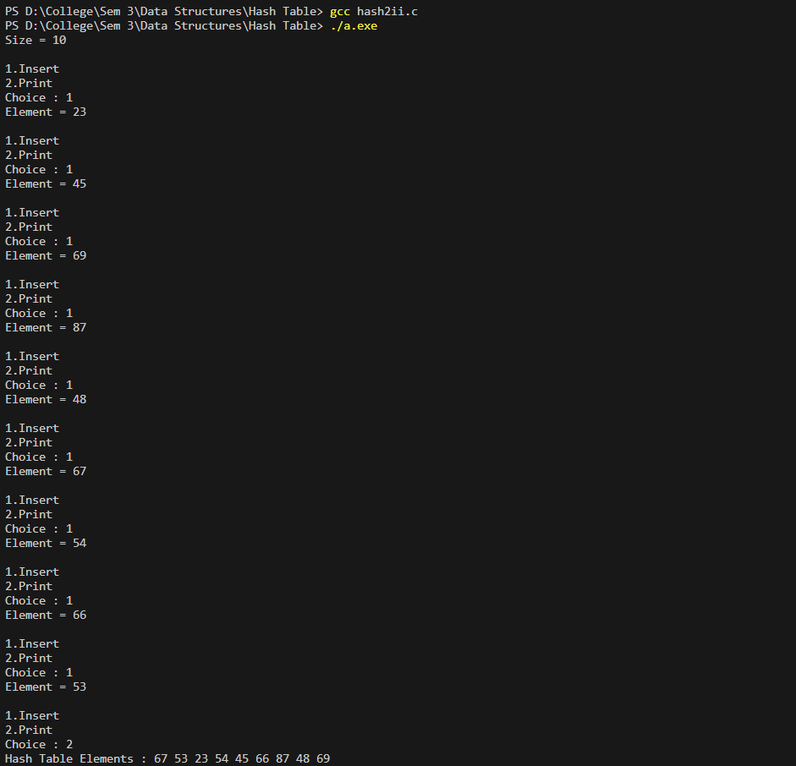

**Learning Outcome:**

